How to get patient info

1. Manually

1st step: Open the run_cdviewer.exe in Patient 7 folder

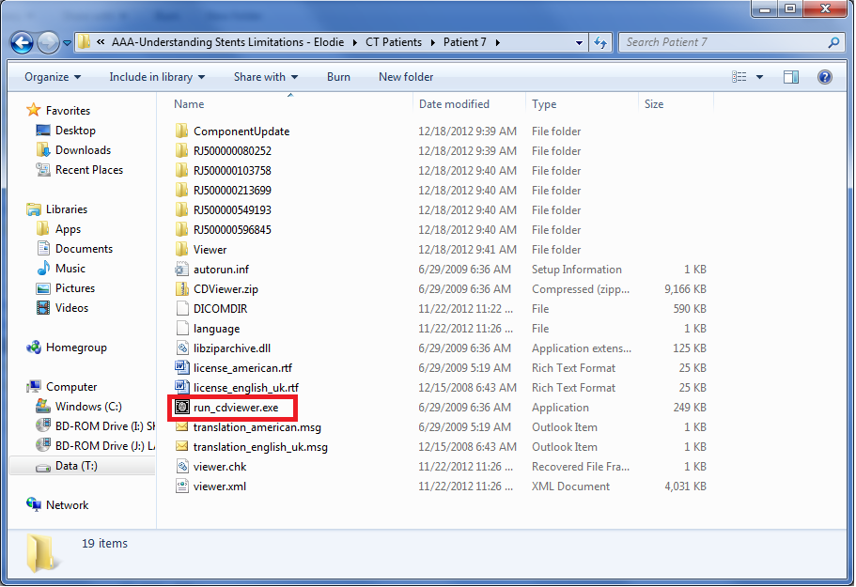

Step 2nd: Look at the Patient CD Index and see how many examine and also the date and time of the examines.

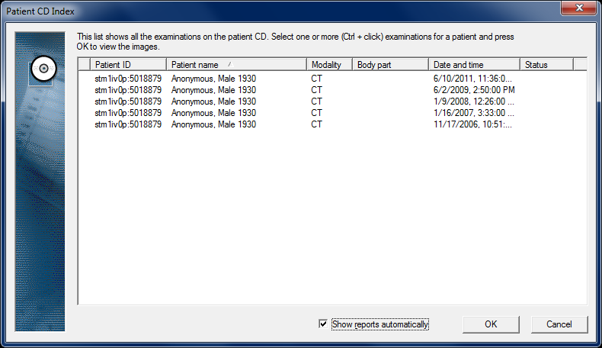

Step 3rd:

Click on the examine then click OK to open Requests and Reports window

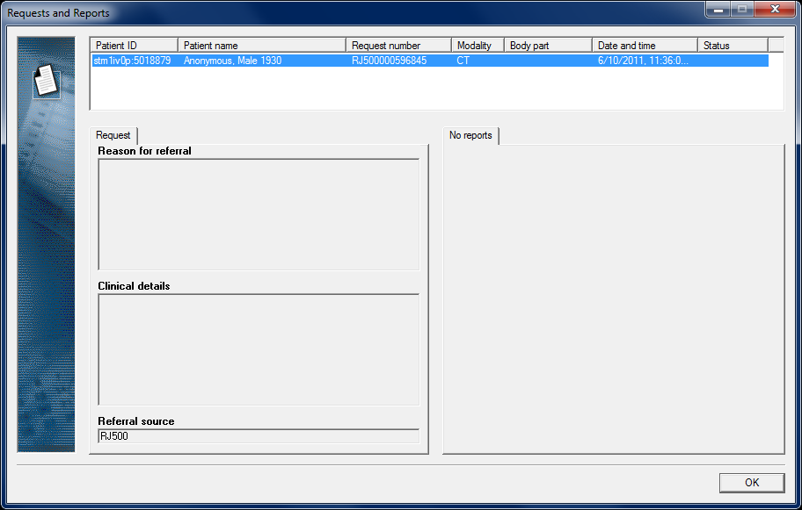

The Request number here (ex: RJ500000596845) is the number corresponding with examine on date 6/10/2011. By using request number, we know which folder contains which examine.

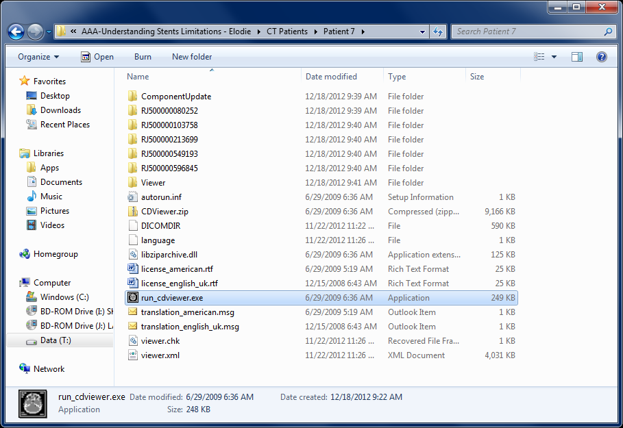



All of other info like: Patient ID (5018879), Name (Anonymous), Birth year (1930), Sex (Male), Number of slide… can easily obtained using the viewer. Contain of the each examine folder is showed in viewer like image below.

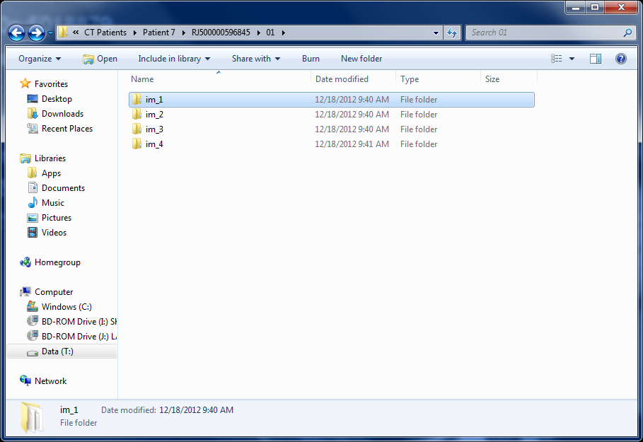

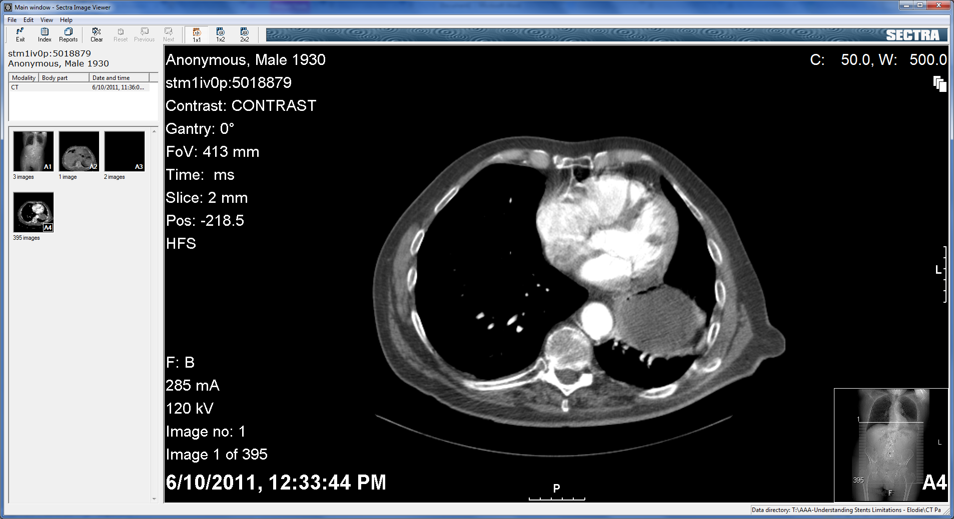

1. Automatically



DIRCOMDIR is the DICOM directory file which has all the info of the DVD contain including patient data, image data, file path, etc… Below is what I got using MATLAB to check on the information

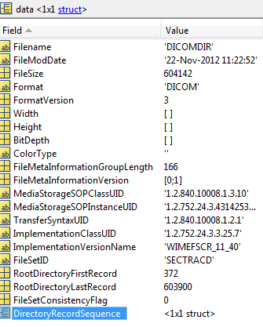 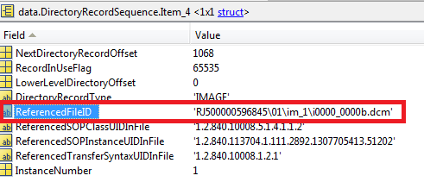

It’s possible to get all the data in DICOMDIR as it is implemented by all CT image viewers. But it requires good understanding how DICOMDIR format is. I hope we can find a good solution for this (open source?)

**DICOMDIR** contents based on the files on **Patient 11**

